ISHITA SRIVASTAVA
202401100200148
MSE-1

GITHUB REPOSITORY URL:
https://github.com/ishita384/github-skills-challenge

Pull request URL used to validate the workflows:
https://github.com/ishita384/github-skills-challenge/pull/1

Screenshot showing the GitHub Actions workflows:
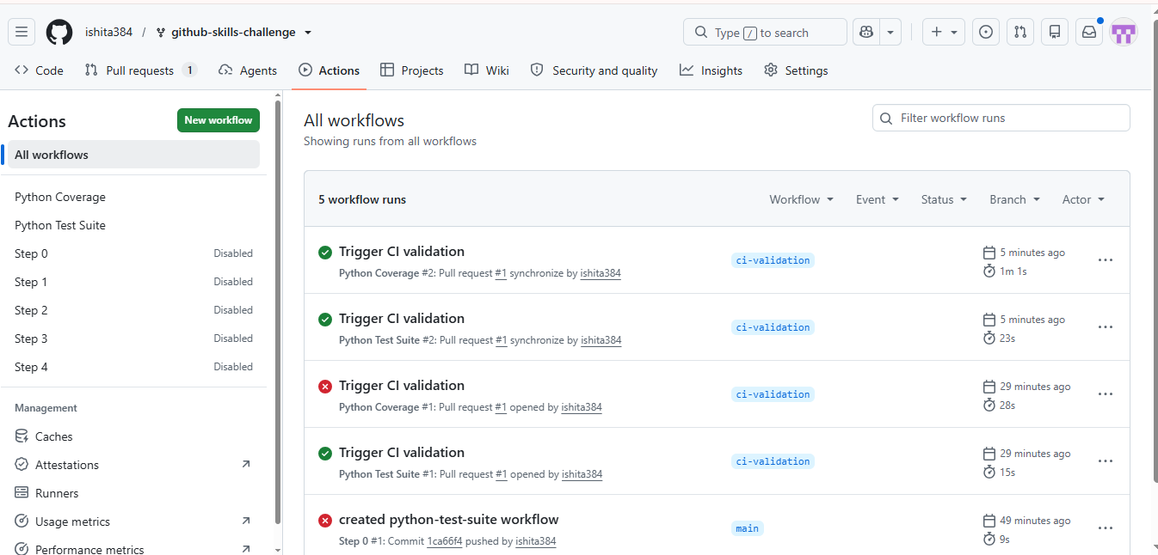

Screenshot showing a successful test workflow execution
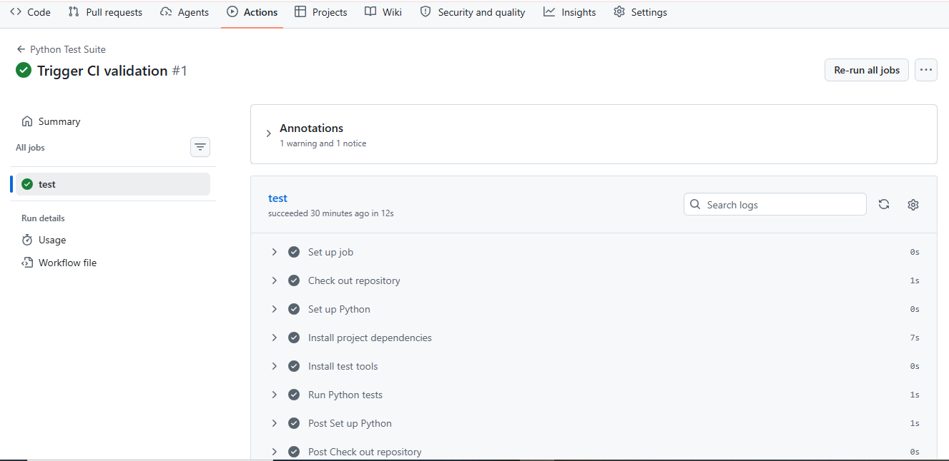

Screenshot showing the coverage result/comment on the pull request:
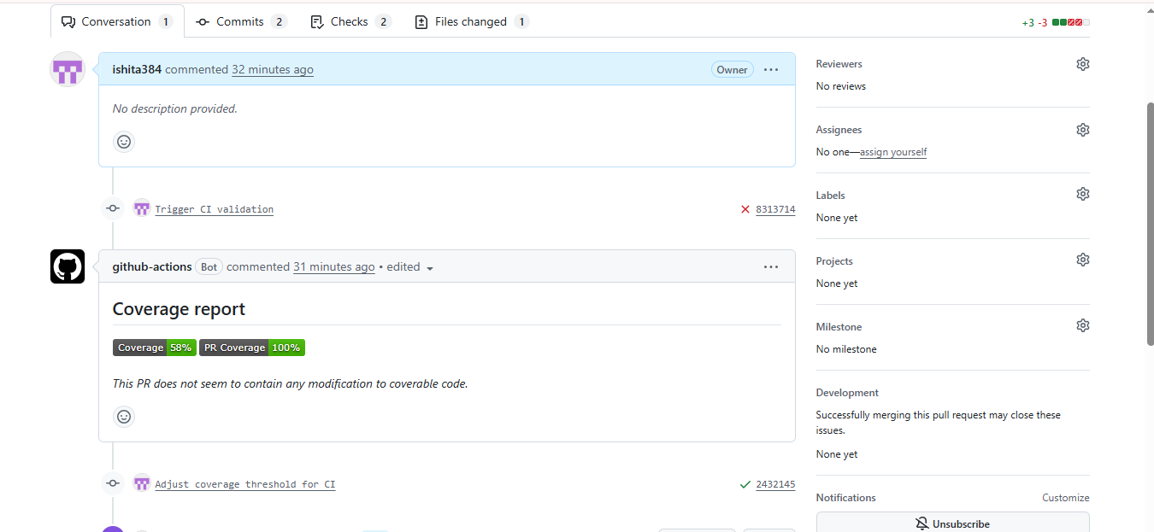

Screenshot showing the final repository/workflow files:
